**Artificial Intelligence (INT404)**

**Voice Based personal Assistant using python**

|  |  |  |  |
| --- | --- | --- | --- |
| Vishal Singh | 11802904 | A08 | K18GA |
| Sahil | 11802017 | A20 | K18GA |
| Kush Sharma | 11802016 | A15 | K18GA |
| Ashish Yadav | 1180 | A14 | K18GA |

**Submitted to: Shabnam: 25660**

**Voice Based Virtual Assistant for Windows**

**Amy**

A virtual assistant is an application that can understand voice commands and complete tasks for a user. Virtual assistants are available on most smartphones and tablets, traditional computers, and, now, even standalone devices like the Amazon Echo and Google Home.

They combine specialized computer chips, microphones, and software that listens for specific spoken commands from you and usually answers back with a voice that you select.

**The Basics of Virtual Assistants**

There are five primary virtual assistants on the market (others exist but aren't as popular):

* Alexa
* Siri
* Google Assistant
* Cortana
* Bixby

Virtual assistants like these can do everything from answer questions, tell jokes, play music, and control items in your home such as lights, thermostats, door locks, and smart home devices. They can respond to many voice commands, send text messages, make phone calls, set up reminders. Anything you do on your phone, you can probably ask your virtual assistant to do for you.

Even better, virtual assistants can learn over time and get to know your habits and preferences, so they're always getting smarter. Using artificial intelligence (AI), virtual assistants can understand natural language, recognize faces, identify objects, and communicate with other smart devices and software.

The power of digital assistants will only grow, and it's inevitable that you'll use one of these assistants sooner or later (if you haven't already). Amazon Echo and Google Home are the main choices in smart speakers, though we expect to see models from other brands down the road.

**Types of virtual assistants**

Though this definition focuses on the digital form of virtual assistants, the term *virtual assistant*, or virtual personal assistant, is also commonly used to describe contract workers who work from home doing administrative tasks typically performed by executive assistants or secretaries.

Virtual assistants can also be contrasted with another type of consumer-facing AI programming, called smart advisers. Smart adviser programs are subject-oriented, while virtual assistants are task-oriented.

**Requirements**

**Hardware Requirements:**

**Minimum System Requirements**

* Processors: Intel Atom® processor or Intel® Core™ i3 processor.
* Disk space: 1 GB.
* Operating systems: Windows* 7 or later, macOS, and Linux.
* Python* versions: 2.7.X, 3.6.X.

**Software Requirements:**

* Python IDLE
* Tkinter module
* Pyttsx3 module
* SpeechRecognition Module
* Wolfram Alpha module
* OS module
* Webbrowser module
* Wikipedia module
* Datetime module
* Roman module
* Python programming language.

**Modular Representation**

**Tkinter**

Tkinter is a Python binding to the Tk GUI toolkit. It is the standard Python interface to the Tk GUI toolkit, and is Python's de facto standard GUI. Tkinter is included with standard Linux, Microsoft Windows and Mac OS X installs of Python.

**Pyttsx3**

pyttsx3 is a text-to-speech conversion library in Python. Unlike alternative libraries, it works offline and is compatible with both Python 2 and 3. An application invokes the pyttsx3. init() factory function to get a reference to a pyttsx3.

**Speech Recognition**

Speech Recognition is an important feature in several applications used such as home automation, artificial intelligence, etc. It can be used on microcontrollers such as Raspberri Pi’s with the help of an external microphone.

**Wolfram alpha**

The Wolfram Alpha Webservice API provides a web-based API allowing the computational and presentation capabilities of Wolfram Alpha to be integrated into web, mobile, desktop, and enterprise applications. Wolfram Alpha is an API which can compute expert-level answers using Wolfram’s algorithms, knowledgebase and AI technology. It is made possible by the Wolfram Language.

**Roman**

Small helper library to convert arabic to roman numerals.

**OS**

The OS module in python provides functions for interacting with the operating system. OS, comes under Python’s standard utility modules. This module provides a portable way of using operating system dependent functionality. The *os* and *os.path* modules include many functions to interact with the file system.

**Wikipedia**

Wikipedia is a Python library that makes it easy to access and parse data from Wikipedia.Search Wikipedia, get article summaries, get data like links and images from a page, and more. Wikipedia wraps the MediaWiki API so you can focus on using Wikipedia data, not getting it.

**Web browser**

In Python, **webbrowser module** provides a high-level interface which allows displaying Web-based documents to users. The webbrowser module can be used to launch a browser in a platform-independent manner.

**Datetime**

In Python, date and time are not a data type of its own, but a module named datetime can be imported to work with the date as well as time. Datetime module comes built into Python, so there is no need to install it externally.

**Implementation** 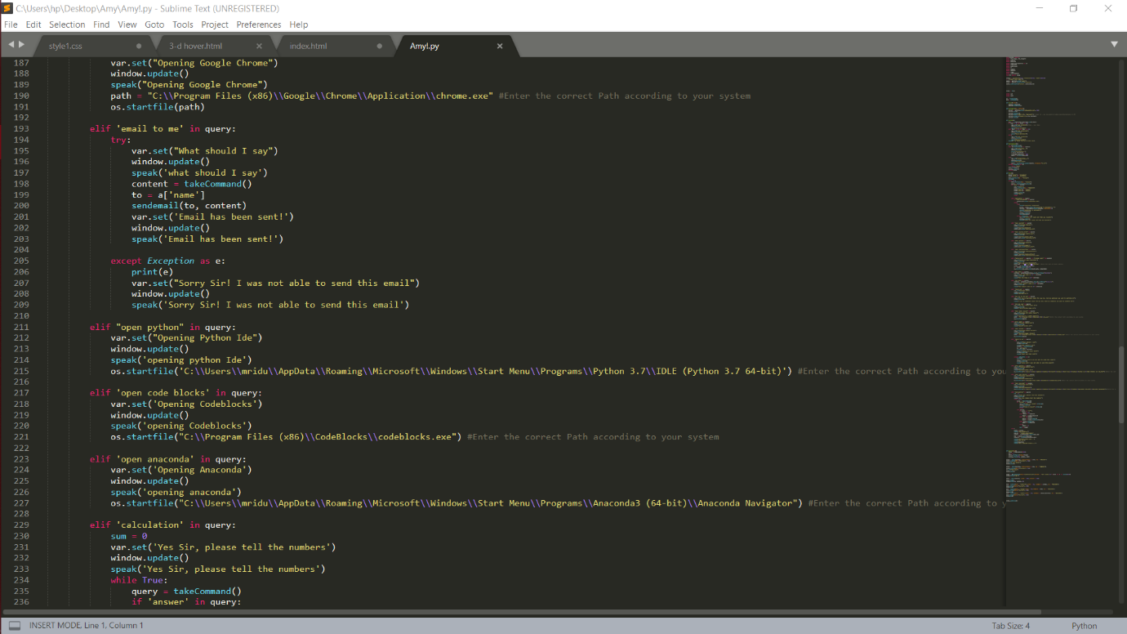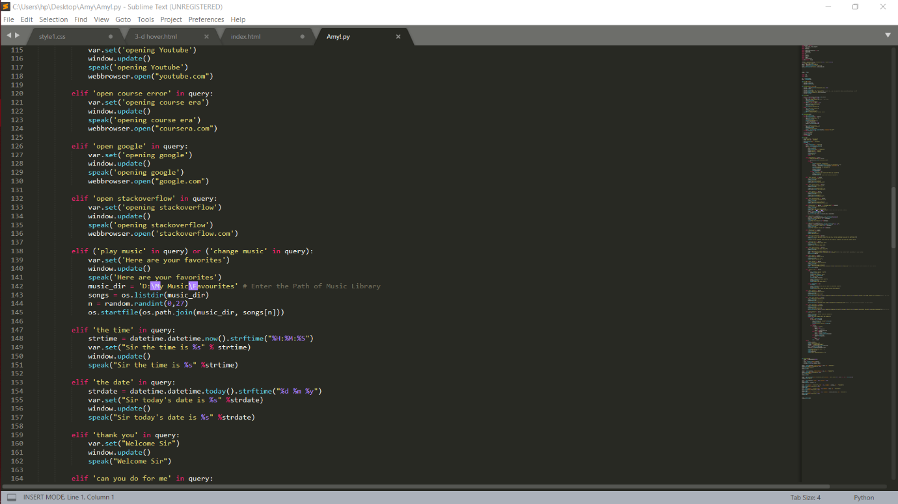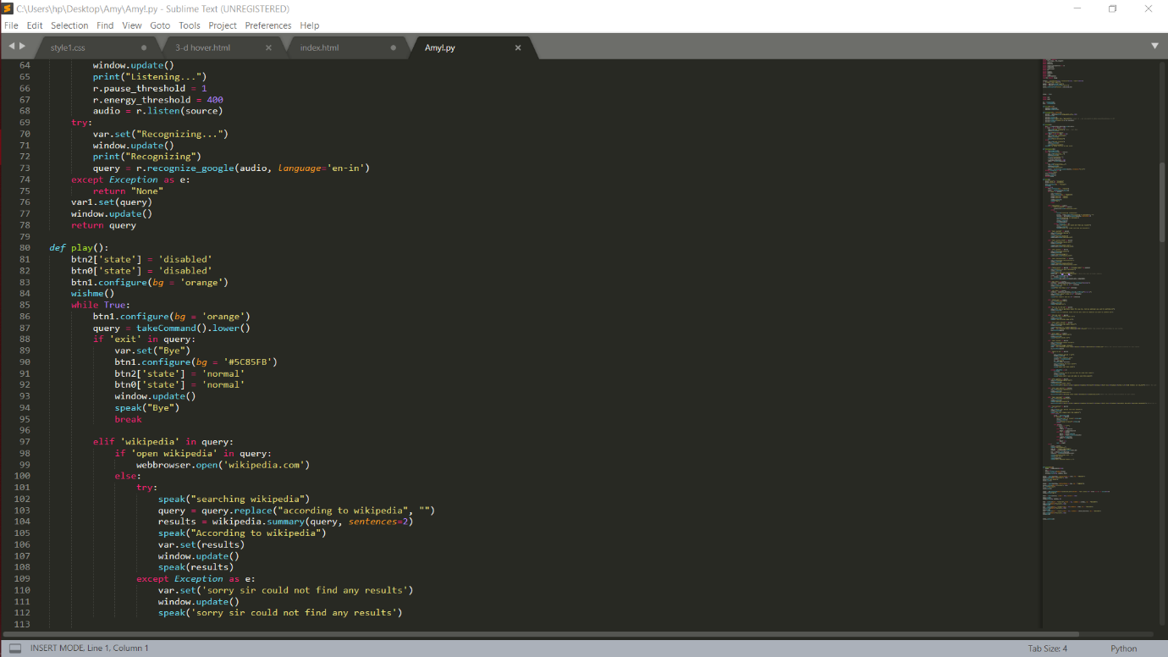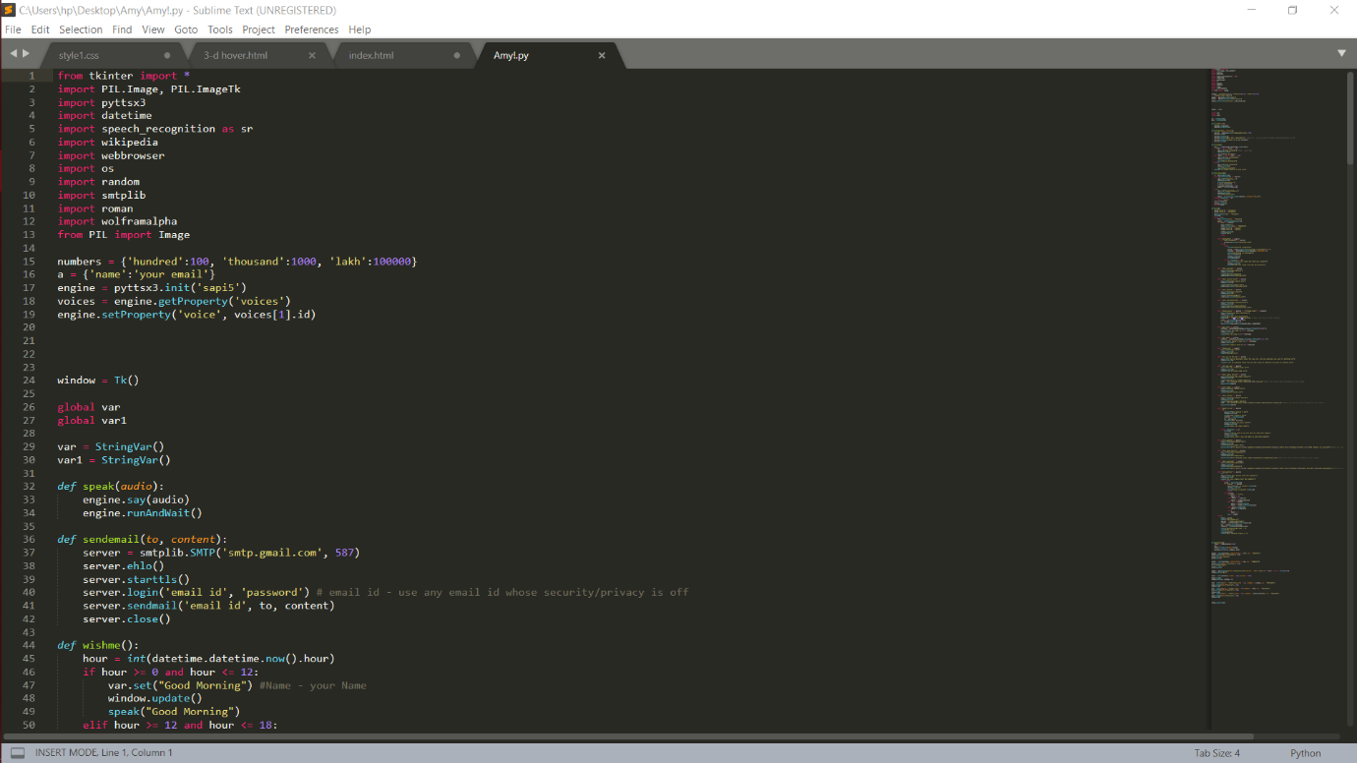

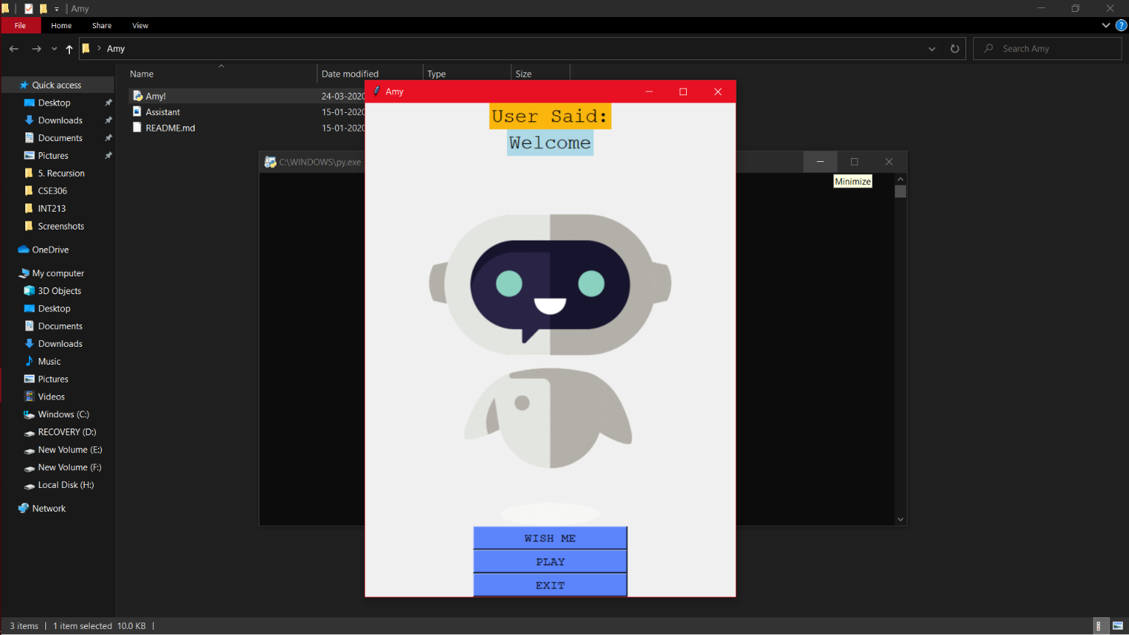

### The future of virtual assistants

Virtual assistants are quickly evolving to provide more capabilities and value to users. As speech recognition and natural language processing advances, so too will a virtual assistant's ability to understand and perform requests. And as [voice recognition](https://searchcustomerexperience.techtarget.com/definition/voice-recognition-speaker-recognition) technology improves, virtual assistant use will move deeper into business workflows.